**ELEC 4700 ASSIGNMENT 1**

**Alice Olorunnife**

**101094593**

**Question 1:**

Thermal Voltage: This was calculated using Maxwell’s principle of equipartition of energy. Each particle has 2 degrees of freedom.

Vth = 1.8702e+05 m/s

Mean Free Path:

mfp = 3.7404e-08 m

Particle Trajectories:

Figure 1: Particle Trajectories

Temperature Plot:

Figure 2: Particle Trajectories Temperature

Explanation:

The particles are all travelling in a random velocity which also dictates the direction the individual particle travels. The electrons have a x component of velocity and y component of velocity. All the particles are travelling at the same random speed. The electrons bounce off the top and bottom of the screen but fly out from the right and re-enter on the left. The second plot is the temperature plot. Since there is no scattering going on and velocity is constant, the temperature is constant as well.

**Question 2:**

Explanation:

This question involves taking the particles before and scattering them randomly. The initial velocities are based on the Maxwell Boltzmann Distribution. This can be seen here:

Pscat = 1 - exp(-dt/Tmn)

The particles are scattering randomly and moving randomly. This was done by multiplying the velocities in the x and y direction by a scattering factor. This makes the particles move erratically compared to how the particles moved in question 1. This results in Figure 3 Below.

Maxwell Boltzmann distribution is the distribution of a particular probability. This question relies on this distribution to influence how particles travel and scatter. In Figure 4 below, the distribution can be seen based on how the particles scattered.

Below in Figure 5, the temperature of the of the scattering particles can be since. Since the particles travel and scatter randomly, the temperature is not constant. This can be seen in the figure.

Particle Trajectories:

Figure 3: Scattering Particles

Histogram:

Figure 4: Maxwell Boltzmann Distribution Histogram

Temperature Plot:

Figure 5: Temperature Plot

Mean Free Path and Mean Time between collisions:

mfp = 3.8565e-06

avgmfp = distancesum/pathnum= 5.9277e-08 m

Tmn = avgmfp/Vth= 3.1696e-13s

**Question 3:**

This question was related to what was done in question 2 but including boxed regions where the particles cannot enter. To ensure this, boxes were made, and a check is done consistently to see if a particle appears in the boxed region. If one does, it is regenerated outside the box. One case is when scattering and boundary conditions were on. This can be seen below in Figure 6. The next is when scattering and boundary conditions are off. This is in Figure 7.

Figure 6: Particle Trajectory Plot (Scatter and Boundary Conditions On)

Figure 7: Particle Trajectory Plot (Scatter and Boundary Conditions Off)

From there, the temperature for both of these cases were temperature mapped in Figures 8 and 9 below. The goal of this was to see how the temperature changed as the particles moved.

Figure 8: Temperature Map when Scattering and Boundaries are On

Figure 9: Temperature Map when Scattering and Boundaries are Off

From there, an electron density plot was created in order to see the probability of where in space electrons are most likely to go. This can be seen in Figure 10.

Electron Density Plot:

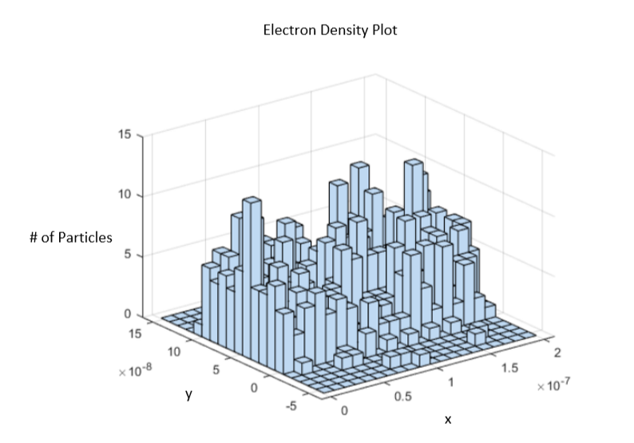

Figure 10: Electron Density Plot